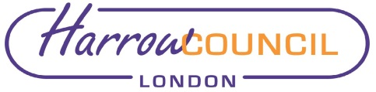

REPORT FOR: |  | COUNCIL
 | Date of Meeting: |  | 16 July 2020
 | Subject: |  | Information Report - Decisions taken under the Urgency Procedure - Council
 | Responsible Officer: |  | Hugh Peart – Director of Legal and Governance Services
 | Exempt: |  | No
 | Enclosures: |  | None

In accordance with the delegations to Chief Officers, the Leaders of each of the Political Groups on the Council were consulted on the following urgent decision, which was approved on behalf of the Council, on the date below as it required action prior to this meeting.

17 March 2020 – Attendance at Council meetings

It was agreed that the need to cancel meetings to limit the transmission of Covid 19 (Coronavirus) be a valid reason under Section 85 (1) of the Local Government Act 1972 why any Councillor may not be able to meet the requirement to attend a meeting within a six month period ending on 30 September 2020.

FOR INFORMATION

Contact:
Elaine McEachron, Democratic & Electoral Services Manager
Tel: 020 8424 1097
E-mail: elaine.mceachron@harrow.gov.uk

Background Papers: Urgent Decision Form.

